POWER BI WEEK 3 PROJECT REPORT

Shop Finance – Stock Market Data Analysis Dashboard

1. Student Details

Name: Keerthana R
Roll No: E25DA024
Department: B.Sc. Data Science and Artificial Intelligence
Tool Used: Microsoft Power BI
Dataset: Shop Finance

---

2. Objective

The objective of this project is to analyze stock market data using Microsoft Power BI. The project focuses on stock prices, daily returns and trading volume using interactive cards, line charts and slicers.

3. Importing the Dataset

The Shop Finance dataset was first imported into Microsoft Power BI.

The dataset contains stock market information such as:

- Date
- Open Price
- High Price
- Low Price
- Close Price
- Adjusted Close
- Trading Volume

---

4. Data Transformation

After importing the dataset, the data was checked and transformed using Power Query.

The required columns were checked for their appropriate data types, especially the Date column and numerical stock price and volume columns.

After completing the transformation, the data was loaded into Power BI for further analysis.

---

5. Creating the Date Table

A separate Date Table was created to perform time-based analysis.

The Date Table was used to create different date-related columns such as:

- Date
- Year
- Quarter
- Month
- Day

These columns were used in the dashboard to analyze stock data across different time periods.

---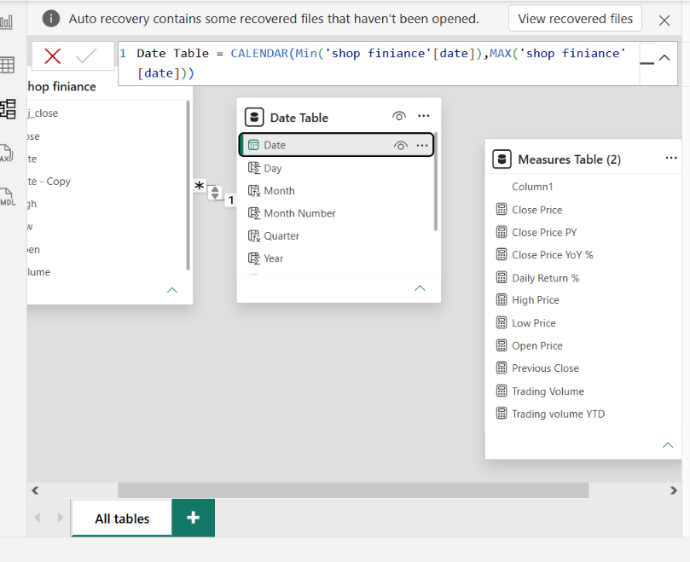

6. Creating New Columns

New calculated columns were created in the Date Table for time-based analysis.

The columns include:

- Year
- Quarter
- Month
- Day

These columns help in analyzing the stock data from yearly, quarterly, monthly and daily levels.

7. Creating the Measure Table

A separate Measure Table was created to organize the measures used in the dashboard.

Measures were created for important stock values such as:

- Close Price
- Low Price
- High Price
- Open Price
- Daily Return
- Trading Volume

These measures were then used to create the dashboard visuals.

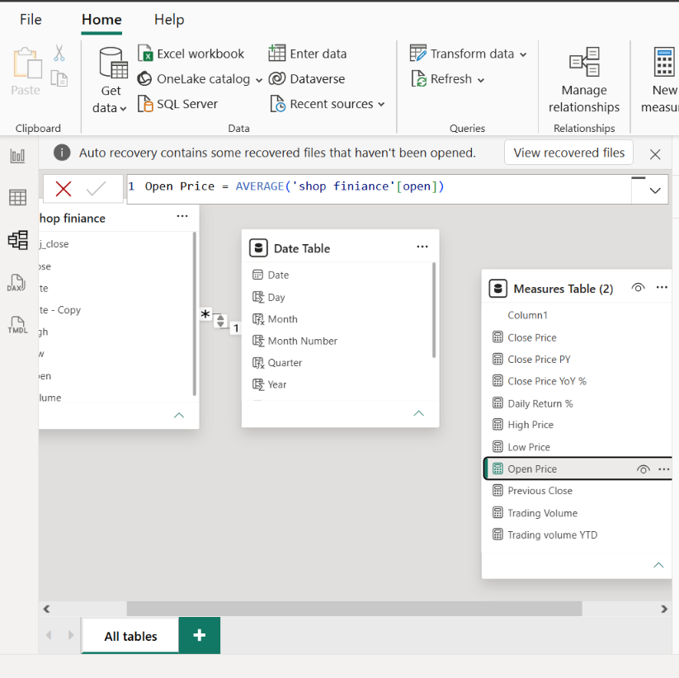

8. Dashboard Visualizations

8.1 Close Price Card

A Card visual was created using the Close Price measure.

It displays the closing price value and provides a quick overview of the stock's closing price.

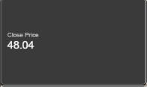

8.2 Low Price Card

A Card visual was created using the Low Price measure.

It displays the low price of the stock and helps identify the lower price level.
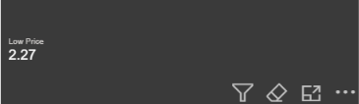

8.3 High Price Card

A Card visual was created using the High Price measure.

It displays the high price and provides a quick view of the highest stock price.
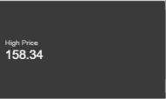

8.4 Open Price Card

A Card visual was created using the Open Price measure.

It displays the opening price of the stock.
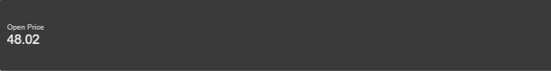

8.5 Daily Return by Year

A Line Chart was created to analyze the Daily Return by Year.

X-axis: Year
Y-axis: Daily Return

This visual shows how the daily return changes across different years.

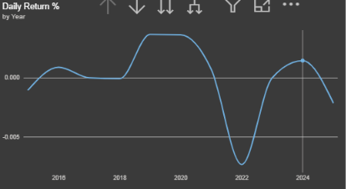

8.6 Open Price by Year

A Line Chart was created to analyze the Open Price by Year.

X-axis: Year
Y-axis: Open Price

This chart shows the movement of opening prices across different years.

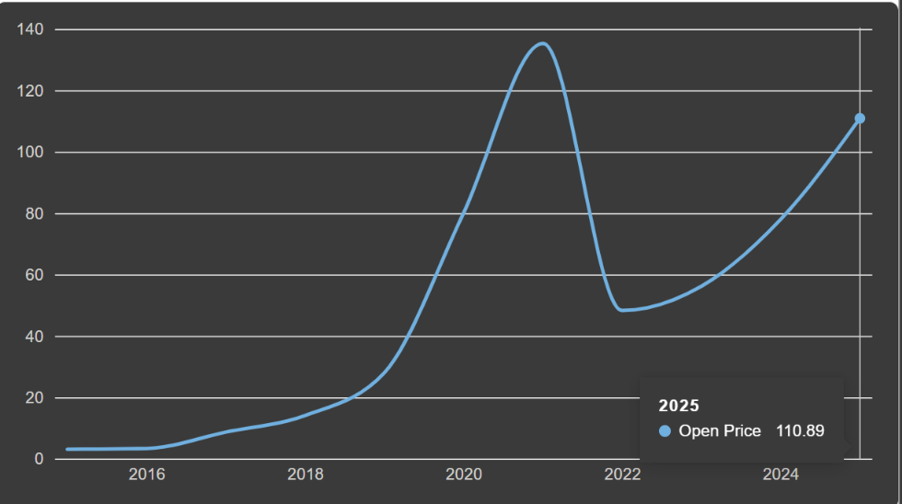

8.7 Month-Year Slicer

A Slicer was added to the dashboard using Month-Year.

The slicer allows the user to select a particular month and year and interactively filter the dashboard data.

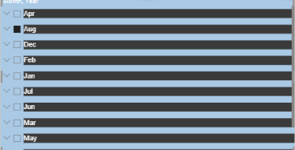

8.8 Close Price by Date

Another Line Chart was created using the Close Price measure.

X-axis: Date
Y-axis: Close Price

The date hierarchy allows the data to be explored through:

Year → Quarter → Month → Date

This visual helps to understand the closing price movement at different levels of time.

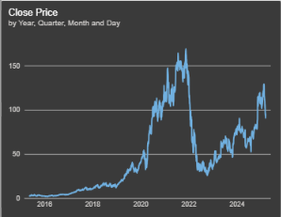

8.9 Trading Volume by Date

A Line Chart was created to analyze Trading Volume by Date.

X-axis: Date
Y-axis: Trading Volume

This chart shows how the trading volume changes over time.

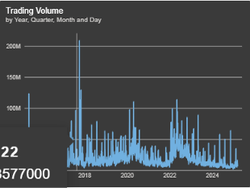

9. Dashboard Interactivity

The dashboard contains interactive features such as:

- Month-Year slicer
- Date hierarchy
- Drill-down functionality
- Interactive cards
- Line charts

The slicer and drill-down features allow the user to explore the stock market data at different time periods.

10. Conclusion

The Week 3 Power BI project demonstrates the process of transforming stock market data into an interactive dashboard. The dataset was imported and transformed, followed by the creation of a Date Table, calculated columns and a Measure Table.

Cards were used to display Close Price, Low Price, High Price and Open Price. Line charts were created for Daily Return by Year, Open Price by Year, Close Price by Date and Trading Volume by Date. A Month-Year slicer was also added for interactive filtering.

Overall, the dashboard provides a clear and interactive way to analyze stock prices, daily returns and trading volume over time.

